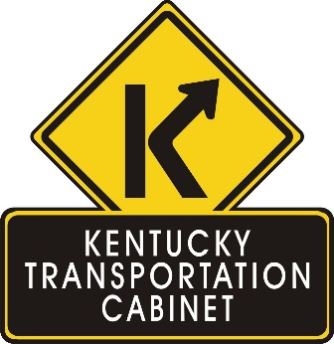

**Kentucky Transportation Cabinet, District 6**

**FOR IMMEDIATE RELEASE**

**Nancy Wood**859-341-2700 (office)  
859-380-4644 (cell)  
<nancy.wood@ky.gov>

**The final piece of KY 9 expansion will complete regional corridor**

*Construction to begin mid-October*

**COVINGTON, Ky. (Oct. 2, 2017)** – Construction will soon begin on the final piece of the KY 9 expansion project in Newport – completing a new 1.4 mile corridor and enhancing regional connectivity.

This project will connect the south end at 9th Street to just south of the roundabout at 5th Street.

“We are eager to complete the realignment and widening of the KY 9 project in Newport,” said Bob Yeager, chief district engineer for Department of Highways District 6 in Covington. “It will be exciting to see how this new corridor will open new opportunities for the city and for the northern Kentucky region.”

Construction on the final section, which will have very little impact to traffic, will begin mid-October and has a December 2018 completion date. Prus Construction Company, of Cincinnati, Ohio, was awarded the low-bid contracts for all three sections of the KY 9 expansion project, including the final section for $4.9 million.

The northern portion of the new corridor from 5th Street to the Taylor Southgate Bridge is currently in progress and will be completed in December. This section includes two roundabouts, one at the end of the 4th Street/Veteran’s Bridge and the other at the end of the Taylor Southgate Bridge, near Newport on the Levee. KY 9 will connect with KY 8 at the southern roundabout.

The southern portion of the new alignment between 12th and 9th Streets was completed in 2016.

The newly expanded KY 9 will have two lanes in each direction with sidewalks and bike lanes. The total cost for all three sections on this corridor project – including design, utilities, right of way and construction – is $45 million.

Safely moving traffic on KY 9 through Newport, improving regional connectivity and increasing utilization of the Taylor Southgate Bridge are the KY 9 expansion project’s greatest benefits to motorists.

###

**Kentucky Transportation Cabinet, District 6 * 421 Buttermilk Pike * Covington, KY 41017**

*Keep up with the Kentucky Transportation Cabinet:*

[cid:image001.jpg@01D1D934.14B49200](http://governor.ky.gov/Pages/index.aspx)[cid:image002.gif@01D1D934.14B49200](http://twitter.com/KYTCDistrict6)[cid:image003.gif@01D1D934.14B49200](http://www.facebook.com/kytc.district6)[cid:image004.png@01D1D934.14B49200](redtapereduction.com)[drivekygov](http://drive.ky.gov/)[cid:image012.png@01D1DB56.7E0C49E0](http://transportation.ky.gov/district-6/Pages/default.aspx)

*Navigate traffic with* [*GoKY*](http://goky.ky.gov/) *or via* [*Waze*](http://waze.com/) *on your smartphone!*